An Internship Report
Of

Web Development Internship: Social Media and E-Commerce Platforms
Submitted
To
School of Computer Science and Engineering IILM University, Greater Noida, U.P.

In partial fulfilment of the requirement of degree of

B.Tech (Computer Science & Engineering)


By
Roll Number of Student: 25SCS1003002832
Name of Student: Nikhilesh Srivastava
Batch: 2025-29

CANDIDATE’S DECLARATION
I, ABIR EKANSH do hereby declare that the internship report titled “Web Development Internship: Social Media and E-Commerce Platforms” has been completed by me to fulfil the requirement for the award of the degree of Bachelor of Technology in CSE. All the references have been quoted and I have not taken as such any material from any other source. I affirm to you that this report is my own and has not been submitted to any other institute for any degree/diploma requirement and further I shall be solely responsible for any kind of copyright violation in this regard.
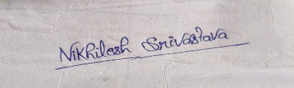

Signature:
Student Name: Nikhilesh Srivastava
Roll No.: 25SCS1003002832
SEC-2CSE18

ACKNOWLEDGEMENT
I am using this opportunity to express my gratitude to everyone who supported me throughout the Internship Program. I am thankful for their aspiring guidance, invaluably constructive criticism and friendly advice during this work. I am sincerely grateful to them for sharing their truthful and illuminating views on a number of issues related to this work.
I express my gratitude to my parents for their blessings.
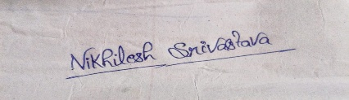

Signature:
Student Name: Nikhilesh Srivastava
Roll No.: 25SCS1003002832
SEC-2CSE18

TABLE OF CONTENTS
Chapter No. | Chapter Name | Page Nos.
1. | Candidate’s Declaration | ii
2. | Acknowledgment | iii
3. | Internship Completion  Certificate | iv
4. | Project Description  4.1 Introduction  4.2 Organization Profile  4.3 Problem Statement  4.4 Project Objectives  4.5 Scope of the Project  4.6 Technologies and Tools  Used  4.7 System Architecture  4.8 Methodology  4.9 Expected Outcomes  4.10 Certificates of completion and other communication mail proof | 1
5. | Bibliography/References | 3

3. Internship Completion Certificate

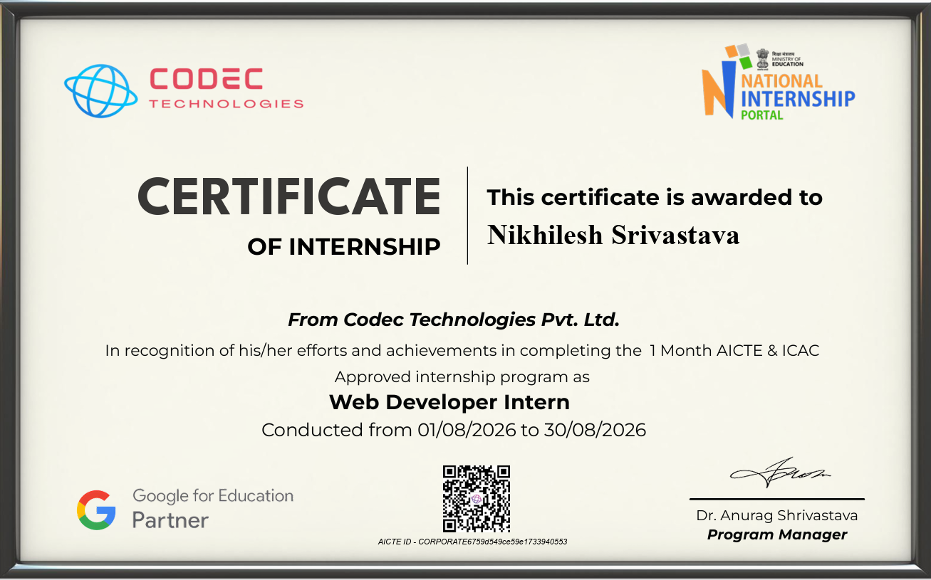

Project Description

Introduction
The internship focused on designing, developing, and deploying modern web applications to solve real-world engagement and retail challenges. Two comprehensive projects were built during this tenure: a fully functional Social Application and an E-Commerce Platform. The social app facilitates user networking and content sharing, whereas the e-commerce project is a digital storefront designed to streamline the online shopping and checkout experience.

Organization Profile
Codec Technologies offers an intensive, industry-focused virtual internship program designed to equip aspiring software engineers with hands-on full-stack development skills. The program emphasizes real-world application architecture, modern JavaScript frameworks, API engineering, state management, and end-to-end deployment.
- Industry-Aligned Learning: Focused on modern web development standards, scalable architectural design, and production workflows.
- Practical Project Exposure: Rigorous implementation of two core web systems: a commercial E-Commerce engine and an interactive Social Networking platform.
- Code Quality & Best Practices: Adherence to modular code structure, responsive design principles, and version control using Git and GitHub.

Problem Statement
In the digital age, users require seamless platforms to communicate, share media, and conduct secure online transactions. Existing platforms can often be bloated or lack specific localized features. The primary challenge was to architect systems from scratch that handle robust user authentication, real-time data flow for a social feed, and secure state management for e-commerce carts and product catalogs without compromising performance.

Project Objectives
- To construct a scalable Social Application allowing users to create profiles, post updates, and interact.
- To develop an E-Commerce system featuring a product catalog, shopping cart functionality, and simulated checkout.
- To implement responsive, user-friendly frontend interfaces that provide optimal experiences across varying screen sizes.
- To design and deploy backend APIs capable of secure database operations and efficient data retrieval.

Scope of the Project
The scope encompasses the full-stack development life cycle. For the Social App, this involves authentication, database schema design for users and posts, and UI/UX design. For the E-Commerce project, the scope extends to product database management, cart session state handling, and rendering dynamic product views.

Technologies and Tools Used
- Frontend Development: HTML5, CSS3, JavaScript, React.js
- Backend Development: Node.js, Express.js (or equivalent frameworks)
- Database: MongoDB / SQL databases for relational data management
- Version Control & Deployment: Git, GitHub

System Architecture
Both applications leverage a structured Client-Server architecture. The frontend layers handle data presentation and state management, communicating asynchronously with backend REST
APIs. The backend services enforce business logic, process authentication tokens, and execute CRUD (Create, Read, Update, Delete) operations against the database.

Methodology
Development followed an Agile methodology. Initial phases concentrated on gathering requirements and mapping out database schemas. This was followed by building and testing backend endpoints. Once the server logic was stable, frontend components were developed, integrated, and styled iteratively based on functionality testing.

Expected Outcomes
The outcomes of this internship are two deployed, robust digital platforms. The social app demonstrates proficiency in managing relational user data and feeds, while the e-commerce project showcases the ability to handle transactional logic, product states, and interactive user interfaces.

Certificates of completion and other communication mail proof

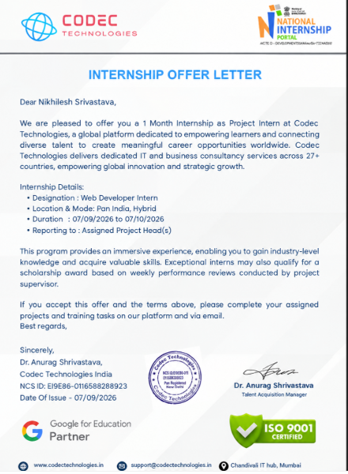

Bibliography/References
Project Source Code 2: GitHub Repository - NikhileshSrivastava/2025-29_NikhileshSrivastava_25scs1003002832_2CSE18

Project Source Code 2: GitHub Repository - NikhileshSrivastava/2025-29_NikhileshSrivastava_25scs1003002832_2CSE18

